WebQuest

Exploring Australia

introduction

Australia is the only country that has a whole continent itself. World famous for its natural wonders and wide open spaces, its beaches, deserts, "the bush", and "the Outback", Australia is actually one of the world's most highly urbanised countries.
Some important facts about Australia:
- National language: English (other indigenous languages are also spoken)
- Population: 21,585,178 (estimated in 2009)
- Area: 7,686,850 km²
- Currency: Australian dollar

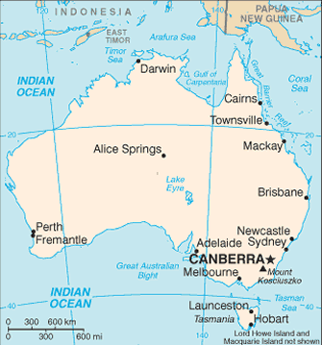

Students will explore Australia in order to create a travel log. In groups of three people you have to find the information in the Internet and organise this travel log of three cities visited.

Task

You will be describing in your travel log a trip between three Australian cities from the list below.
CANBERRA, the capital city

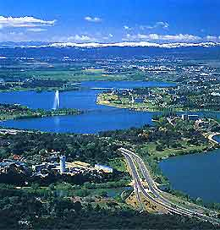
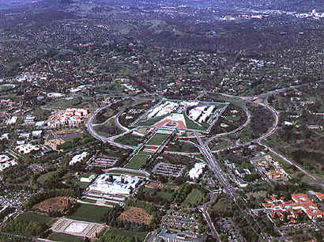

SYDNEY, the largest city

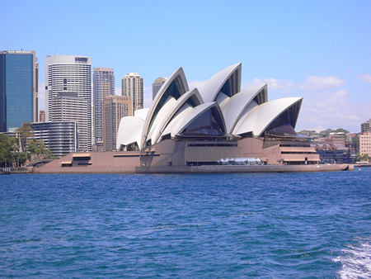
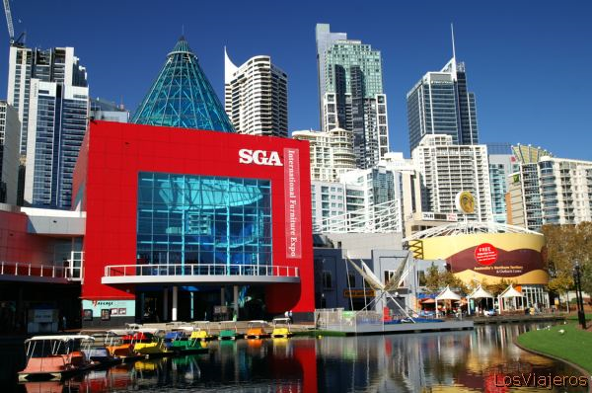

MELBOURNE, the Australian sporting and cultural capital
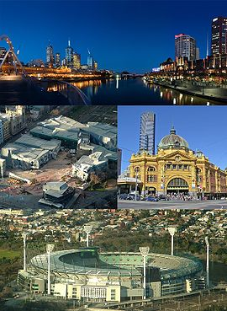

PERTH
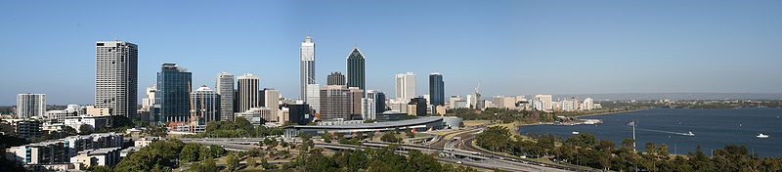

ADELAIDE
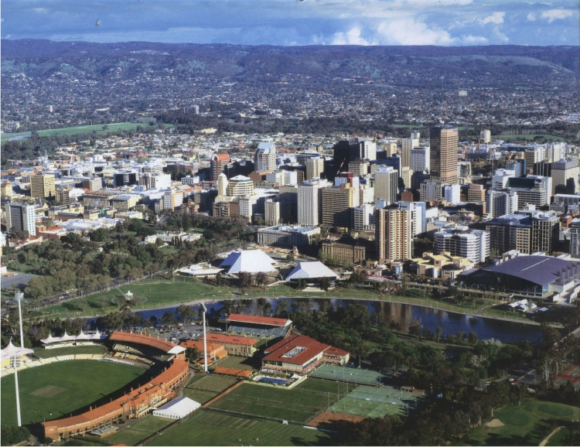
BRISBANE
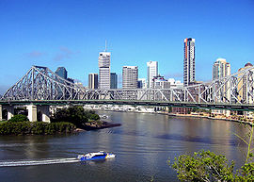

DARWIN
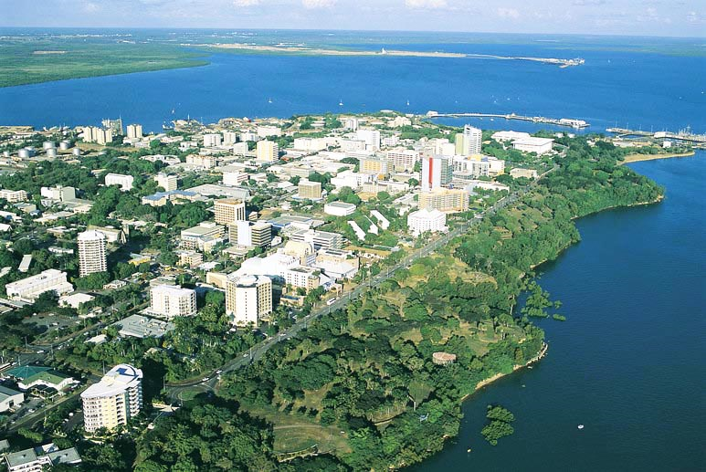

ALICE SPRINGS, the traditional Australia

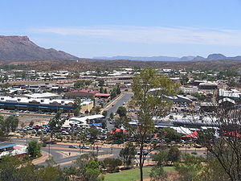
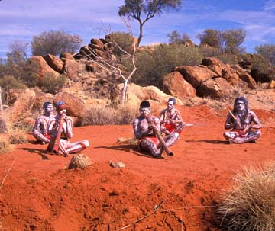

Process

In order to fulfil this WebQuest, follow these steps:
- Get into groups of three.
- Pick the three cities you wish to include in your travel log. The travel log will look like a brochure and will include interesting facts about the cities chosen.
- Use the websites in “Resources” to look for the following items of every city:
  - the state it belongs to
  - a cultural point of interest such as theatres, museums, sports, etc.
  - important historical facts
  - important geographical features (nearby rivers, mountains, beaches, etc.)
  - population numbers
  - any other remarkable feature
- Now that you have researched your three Australian cities, organize and create the travel log. The way of presentation of the travel log is a decision of the group but it must include pictures and photos to "liven up" your travel log. After all, you want people to travel to your city, so make it look nice!

Resources

Use the following links to find information needed to create your travel log for your three cities.

Wikitravel - http://wikitravel.org/en/Main_Page
Use the Wikipedia website to find facts - http://en.wikipedia.org/wiki/Main_Page
Tourism Ausralia - http://www.australia.com/index.aspx
Visit Western Australia - http://www.visitwa.com.au/index.php
Google - http://www.google.com

Evaluation

Your project will be evaluated in terms of:
- Participation of ALL group members
- Correct grammar, spelling, and vocabulary
- Visual presentation and creativity
- Use of web-based resources
- Suitable contents for each city

Your final performance will be evaluated by the teacher according to the following evaluation sheet:
 | Excellent | Average | Poor
Content | All facts in the brochure are accurate.  The information about the three cities was very complete, and well selected. You haven't copied and pasted it. | Some of the facts in the brochure are not accurate. There is a lack of some important events of the three cities. You have just copied and pasted some of the information. | Most of the facts in the brochure are not accurate. The information about the three cities was very incomplete. You have copied and pasted most of it.
Presentation | You have organized the information in a good manner. You have included some pictures that make your work more attractive. | You have not organized the information very clearly. The pictures included are not very well situated or selected. | The have organized the information in a messy way. You haven't included any pictures.
Group work | There is a clear cooperation within all members of the group. | You have cooperated with each other but there is a disparity of work within the group. | You haven't cooperated and haven't supported each other.
Language awareness | You have very few grammatical or spelling errors. None of them are very important. Good vocabulary used. | You have an average number of important grammatical and spelling errors. Some good vocabulary used. | You have a lot of important grammatical and spelling errors. Vocabulary not accurate.

Conclusion

After completing your task successfully you should have learnt:
- To use the Internet as a useful tool to search information about other countries
- To organise group work and share information to reach an agreement
- To consider how important visual presentation is
- New vocabulary in connection with travelling
- Geographical, historical and cultural information about Australia

